Flooding in Manitoba Test
Name: ___________________________ Date:_________________________

Part 1: Flooding in Manitoba
- What were the 9 main causes of the “Flood of the Century? Circle the letter of the 9 best choices:

- Ice Jams along the Red River
- Large Sumo wrestlers belly flopping in Lake Winnipeg
- Dam collapsed in Grand Forks, North Dakota
- Ground was still frozen during the spring melt
- Heavy fall rains
- There was plenty of snowfall and blizzard during the winter
- Strong winds sent large waves and water north to Winnipeg
/ 9
- Winnipeg’s ring dike didn’t hold the flood water
- Rapid snow melt or thaw in the spring
- The Red River valley soil has lots of clay and doesn’t absorb and hold water
- Flood waters from Lake Manitoba and the Shellmouth reservoir entered the Red River
- Late spring blizzard dumped a lot of snow all at once
- Ryan was swimming in the Red River and passed gas
- Heavy spring rains
- The Red Sea swept pass the Brunkild Dike and into the La Salle River
- Water enters the Red River from parts of Saskatchewan, North Dakota and Minnesota
- A significant hail storm in March

- Name 8 methods that the province of Manitoba uses to stop or prevent flooding?

*
*
*
/ 8
*
*
*
*
*
- The following map shows what the province of Manitoba uses to fight floods. Name the parts of the map that are labeled A – G.
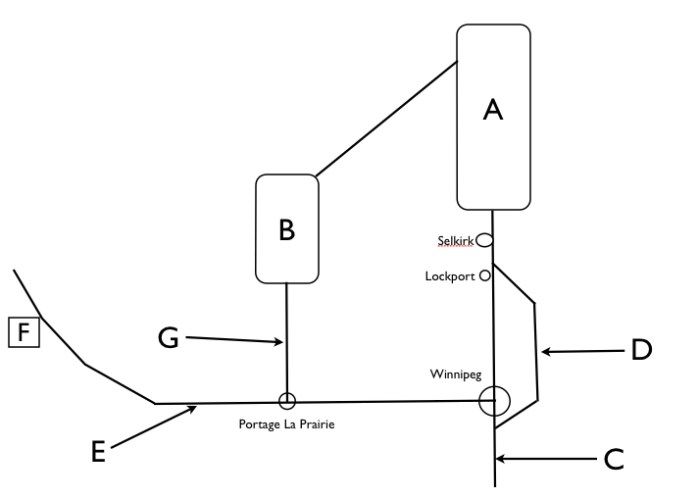
/ 7
A________________________________
B _______________________________
C________________________________
D _______________________________
E _______________________________
F _______________________________
G _______________________________

- Name 3 towns in the Red River Valley that were affected by the flood
/ 3
_____________________________________ ________________________________
_____________________________________

- a) In what year did the “flood of the century” take place? _________________ .
b) The government of Manitoba decided to build a floodway after the flood of which year ? ______________ .
c) What was the name of the Manitoba Premier who was instrumental in the construction of this floodway ? __________________________________
d) When the floodway gate is down, water backs up and is diverted into the floodway. True or False ? ______________
e) What is the name given to the place where the floodway rejoins the Red River at Lockport just past the floodway bridge ? ____________________
/ 10
f) The floodway goes around the East side of Winnipeg. True or False ? ______________
g) In today’s dollars, it cost about 360 million dollars to build the floodway. True or False ? _____________
h) Although the Red River became the “Red Sea”, every town was safely protected by a ring dike. True or False ? ______________
i) Had the “Red Sea” continued to flow Northward and join this river, water would have missed the floodway and flooded Winnipeg. __________________________
j) From 2005-2010, what happened to the floodway ? ________________________________
Part 2: About Water
- Manitoba is located in the _________________________ drainage basin.
- Lightly shade this basin on the map below.

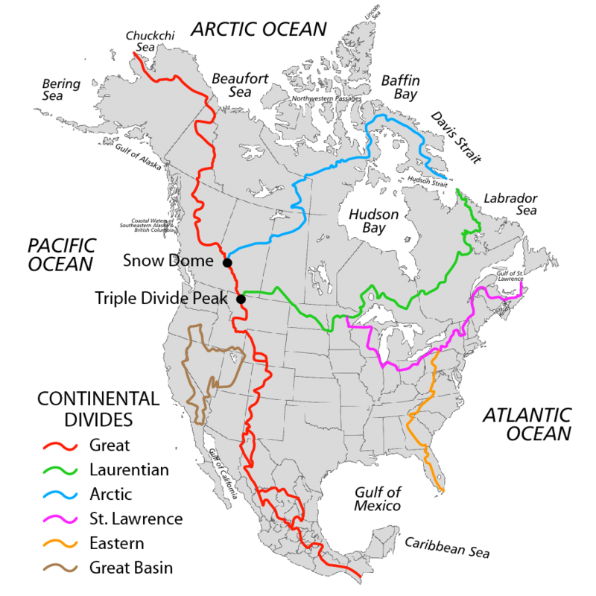
/ 6

- Which letter best describes the water cycle:

- precipitation – surface water – condensation - evaporation
- condensation – precipitation – surface water - evaporation
- surface water – precipitation – condensation - evaporation
- evaporation – precipitation – condensation – surface water

- The water in our world is about ________ % fresh water and ________ % salt water.

- A boat will float higher in fresh water than salt water. True or False? ____________

- What type of water would you find at the bottom of an ocean (circle 2):
cold hot salty not salty
7) Differences in saltiness and warmth of water helps to create ________________________________.
8) Which of Earth’s fresh water sources has the lowest percent ? Circle the best choice
- atmosphere
/ 3
- groundwater
- lakes/rivers/swamps
- icecaps and glaciers
9) You drill a hole deep into the ground. After 30 minutes, you finally reach water. What is the name of this place ? _______________________________________

Part 3: History of the Red River
- Most of Manitoba was once covered by this lake which formed when the glaciers melted 9500 years ago. ________________________________
- The Red River begins in the United States, on the border of these 2 states: _____________________________ and _______________________________ .
- The Red River is 885 Km long: 635 Km are in Canada and 250 Km are in the U.S. True or False ? ______________

- The Red River falls _________ meters on its trip to Lake Winnipeg. It spreads into the lake at the huge delta wetland known as ___________________________.
/ 8
- The Red River flows into Lake Winnipeg, then the __________________ River and ultimately into Hudson Bay.

6) Is the Red River a young or old river ? _______________
7) Where is it better to own river front property?
- As far away from your teachers as possible
- In the small town of Bamboola Dingy Boing, Manitoba where property is hot, hot, hot!!!
- On the inside of a meander
- On the outside of a meander

8) The Forks is a famous place in Winnipeg where Europeans and First Nations peoples traded. This is also where the Red River and the _______________________________ River meet.
9) Place the words in the word bank in the “young rivers” column or the “old rivers” column (there should be 6 words in each column).
Word Bank

wide blind fast-flowing straight V-shaped channel slow-flowing more erosion small sediment narrower
large sediment U-shaped channel toothless
deaf less erosion meanders

YOUNG RIVERS OLD RIVERS
/ 6

_________________________ _______________________
_________________________ _______________________
_________________________ _______________________
_________________________ _______________________
_________________________ _______________________
_________________________ _______________________

10) When the original Upper Fort Garry near the Forks was destroyed in 1826, Governor George Simpson decided to build Lower Fort Garry at its current location for 2 reasons: 1) It was on higher ground so it wouldn’t flood again and 2) _______________________________________________
_______________________________________________________________________________ .
/ 2

11) The St. Andrews Lock and Dam blocks the flow of the Red River because:
- There would be too much water in Lockport and it would cause significant erosion
- It raises the water level so that boats can pass through it
- It raises the water level so Ryan and his friends can catch bigger catfish and make his grandmas world famous “beer battered catfish and chips”
- It raises the water level so the water can flow into Lake Winnipeg at a much slower rate
- It raises the water level on the Red River south of the bridge so boats can travel on it

Bonus Question

What is an oxbow lake ?

- A lake that is formed on a flat meadow in the mountains.
- A lake that is formed when a fast flowing river cuts off a meander
- A lake that is formed long ago when aboriginal people hunted for wild Ox with their bow and arrows. They dug out huge burial grounds and the land has now filled with water, forming an “oxbow lake”.
- A lake that is formed by waterfalls

Part 1: Flooding in Manitoba ______________ / 37
Part 2: About Water ______________ / 9
Part 3: History of the Red River ______________ / 16

Bonus Question: ______________ / 1

Final Mark: ______________ / 62 = ________________ %

