How To Join and Participate In a Meeting On Teams

For Students

- The best way to use Teams is by downloading and using the Teams app since it is a richer user experience. Click for link. You can also access Teams through your Microsoft Office 365 through your web browser.
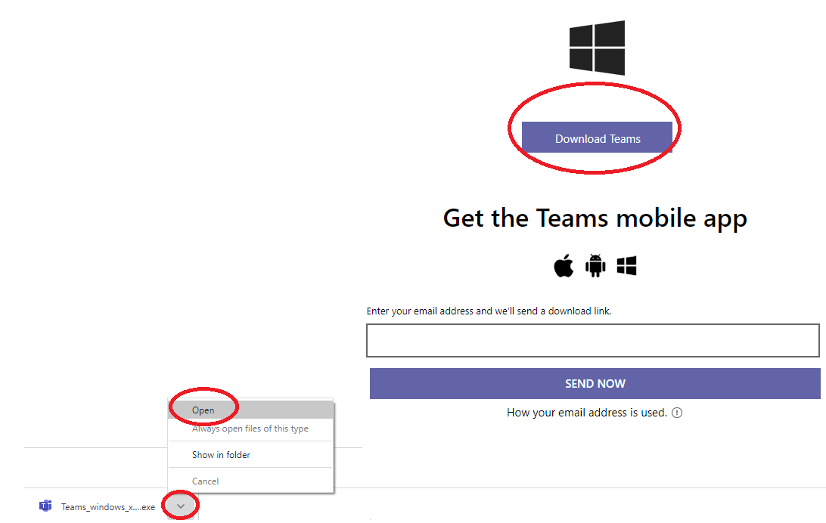

- Sign in using your LSSD email and password:
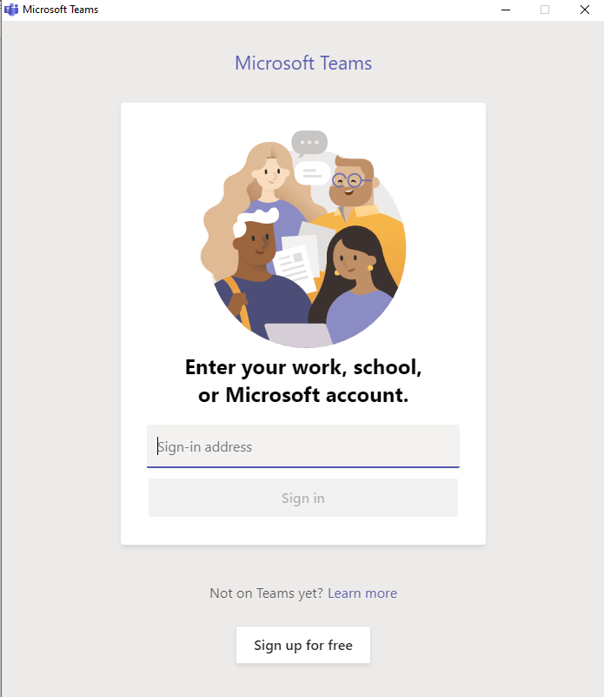

- Once you are signed into the Teams App, you will see a screen similar to this one.

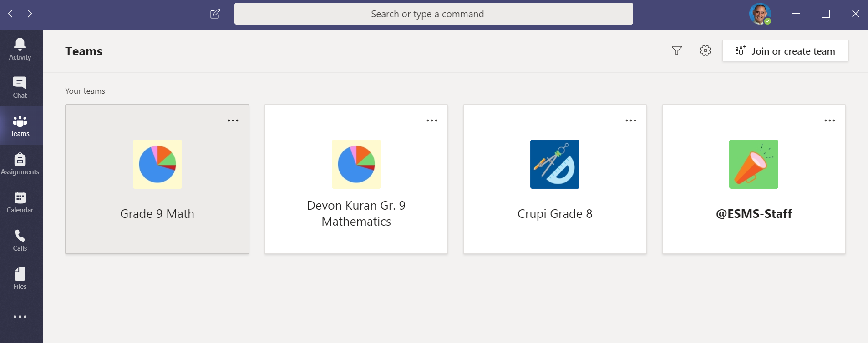

- To join your scheduled meeting:

- Select “calendar” on your charm bar (left side)
A. Click Here

- Then click on your meeting box
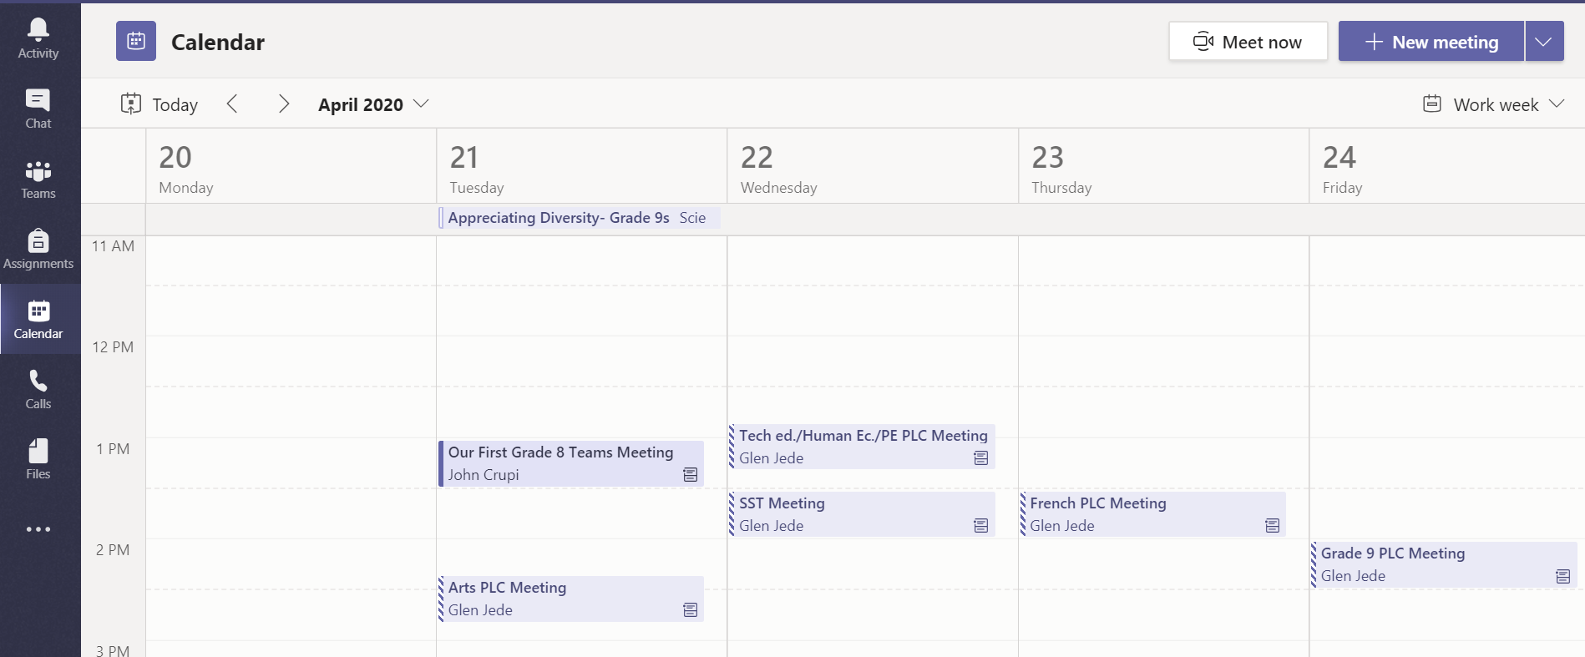
B. Click Here
- Select “Join”.
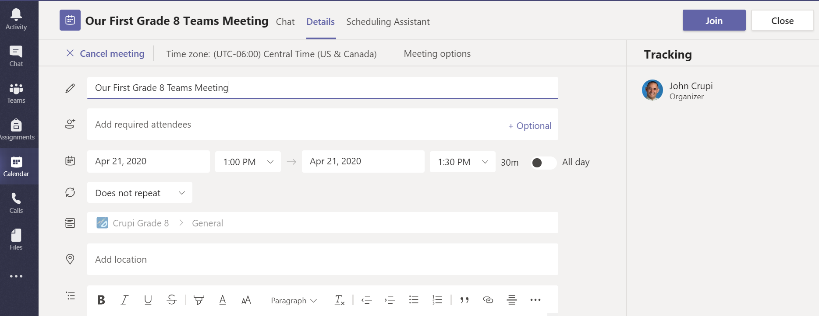
C. Click Here

- Turn your camera and your microphone OFF and select “join now”
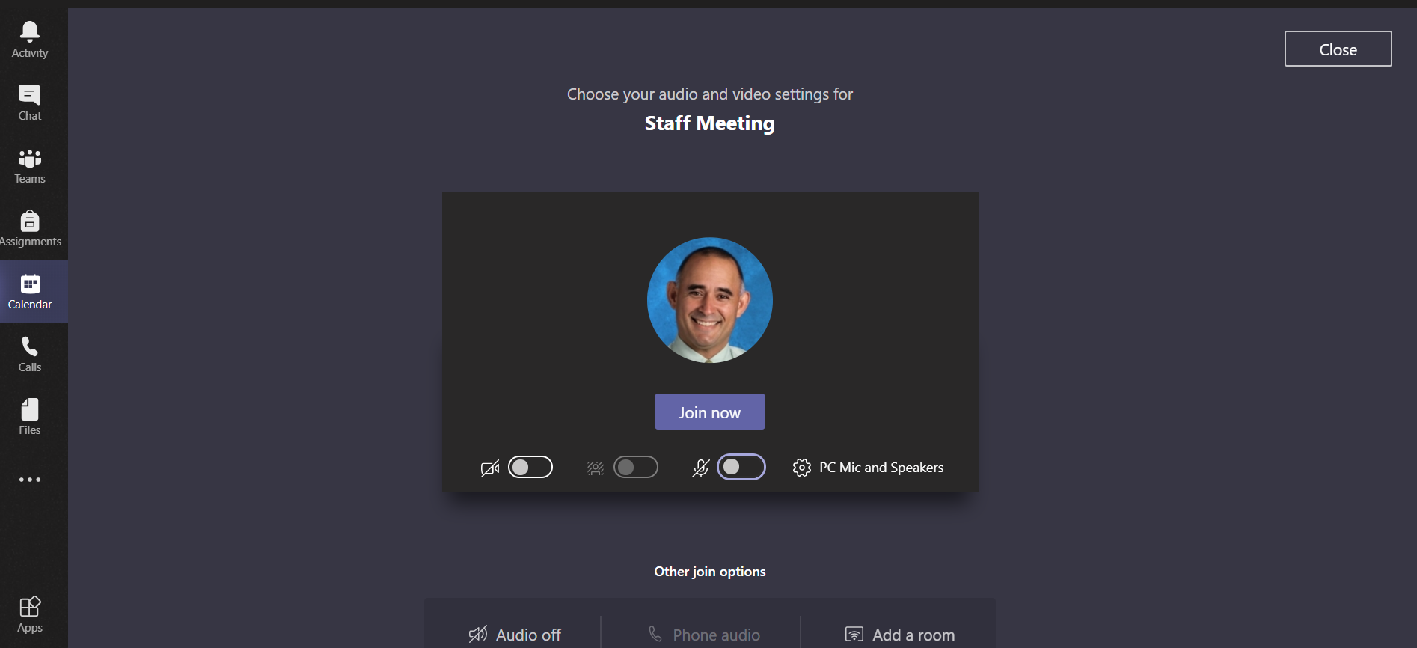

D. Click here
D. Microphone OFF
D. Camera OFF

- In meeting:

Locate the “Call Features” bar showing up across the top of your screen. In this call, the camera is off and the microphone is muted. Study the diagram below to learn what each icon can do.

Click to end meeting
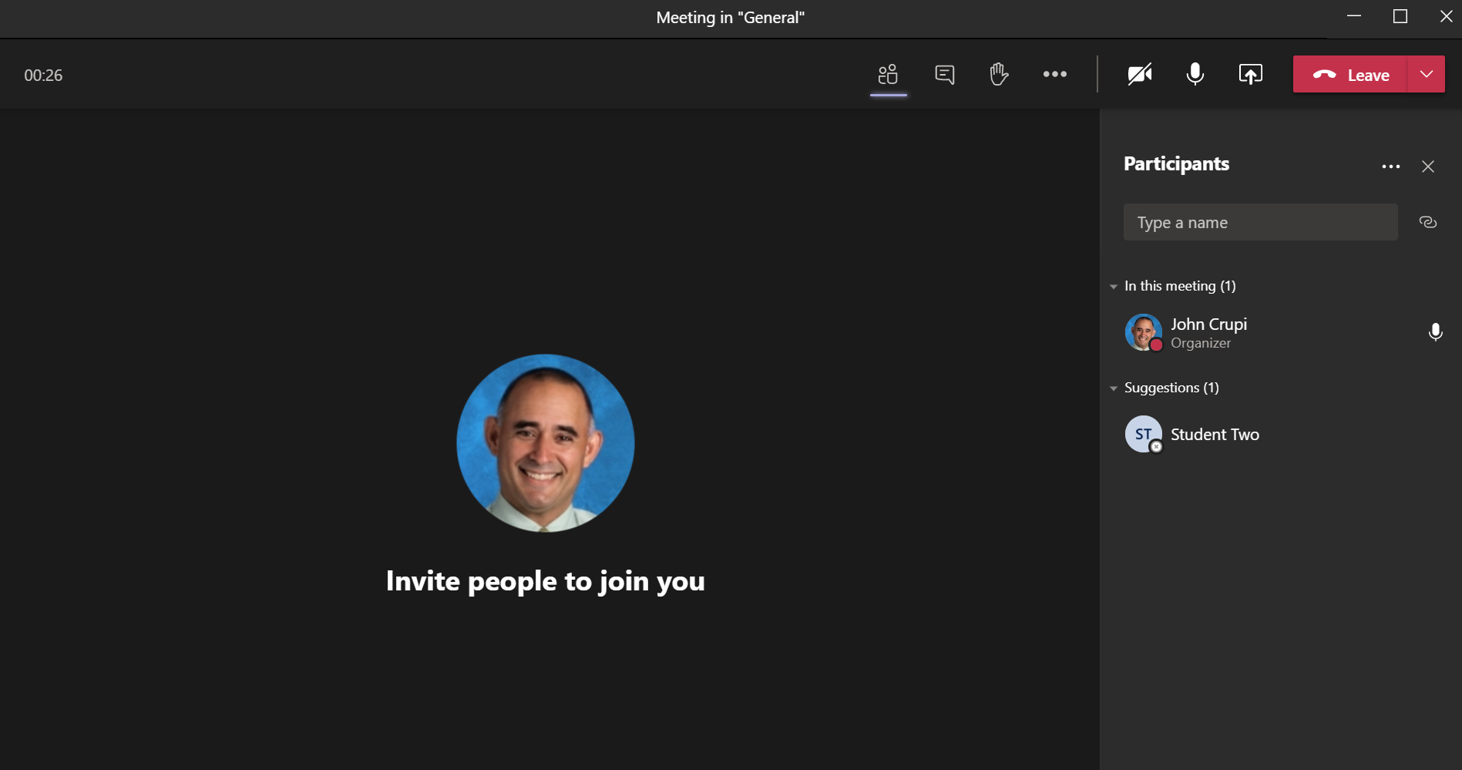
Your teacher will select this to share what is on their screen. You will not have access to this.
Shows participants
More Options – volume settings are here
Select “raise hand” to let your teacher know you have a question
Send a message by text
Camera off/on
Microphone off/on

Teams Meeting Rules and Expectations:
- Find a comfortable working space in your home. You should have supplies and it should be quiet so let family members know when the meeting is taking place.
- Please turn off your microphone and camera unless you’ve been asked to speak or would like to speak. We will have a better connection when both are turned off plus it will be less disruptive if your microphone isn’t picking up any background noise that you or others might be making.
- If you are disruptive at the meetings even after requests to stop your behavior, you could be muted from the meeting or possibly removed from the meeting and will need to make up the time at the end. My first choice is to always have you stay!
- You are expected to attend every scheduled meeting. However, if for some reason you can’t attend a class meeting, you can watch them later as they will be recorded.

How To Watch a Video of the Recorded Class Meeting

In the screenshot below, the teacher has recorded his first lesson in the “Math and Science” channel.

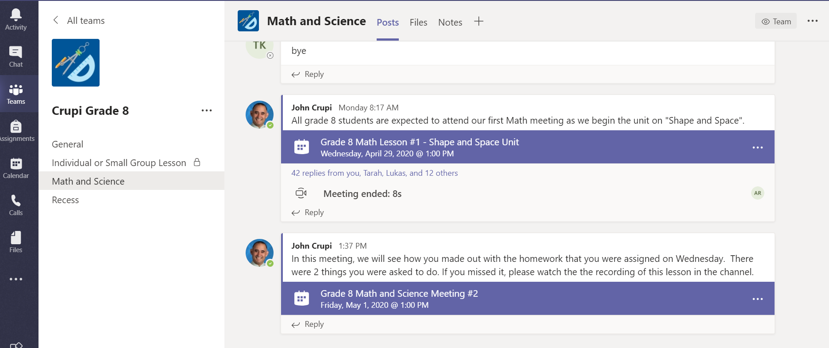
2. Find the meeting banner and click here to see the notes of the meeting.
1. Select the channel in your team where the recording was made

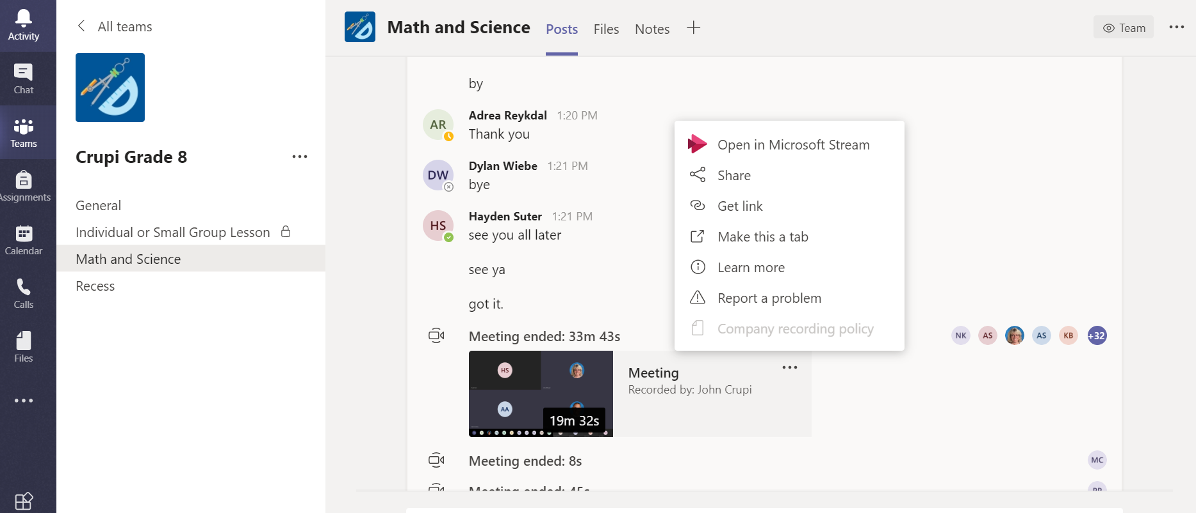
4. Select the 3 dots beside the thumbnail and then select “Open in Microsoft Stream”.
3. Scroll down until you see the video thumbnail. Double-click to play. If it doesn’t play, go to step 4.

