How to Use Class Notebook To Complete Assignments

For Students

Creating a Classroom Notebook Through Teams
- Open Teams on the desktop
- Select your Team
- Select the general channel and “Class Notebook” at the top
- Select “Open in Browser” and then “Open in Desktop App”. This will open your One Note Class Notebook and take you to your “welcome” page.

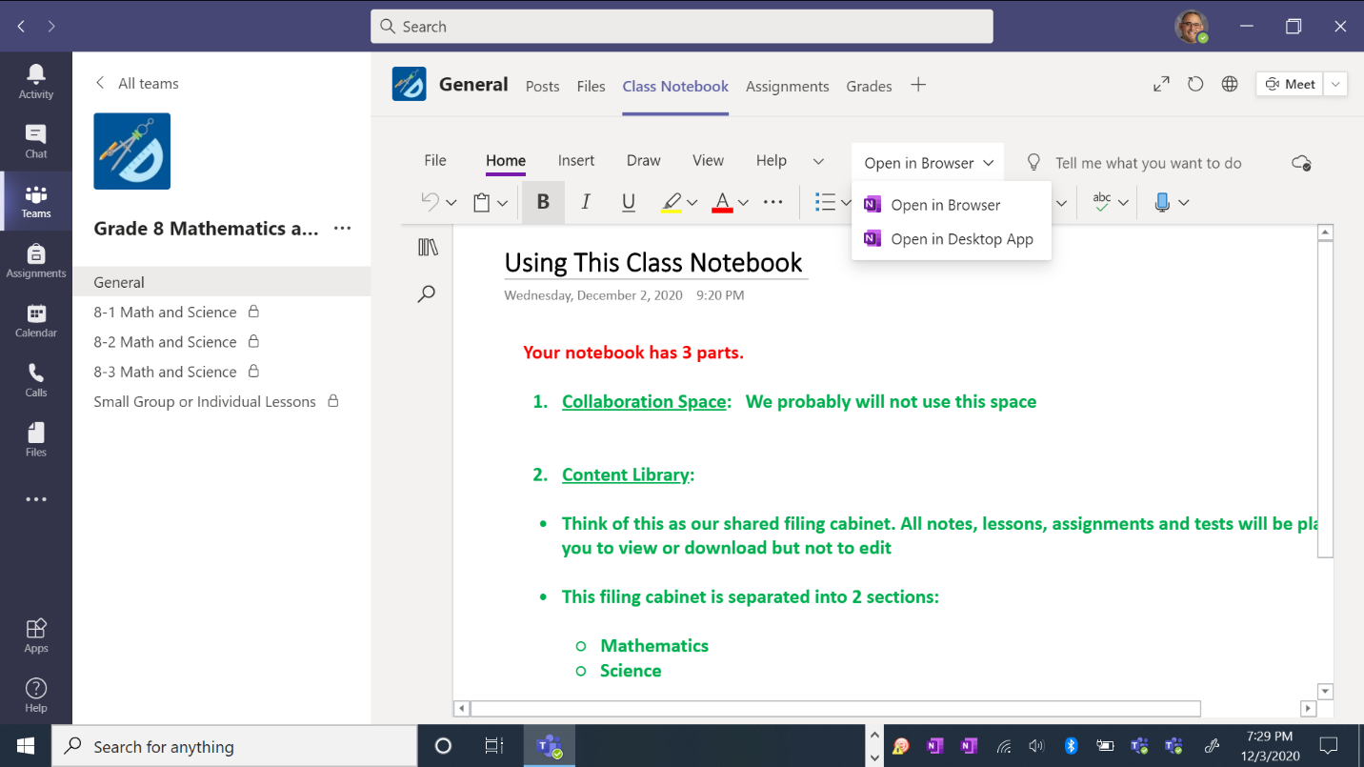
Select Open in Browser and then Open in Desktop App
Select the Class Notebook
Select the general channel

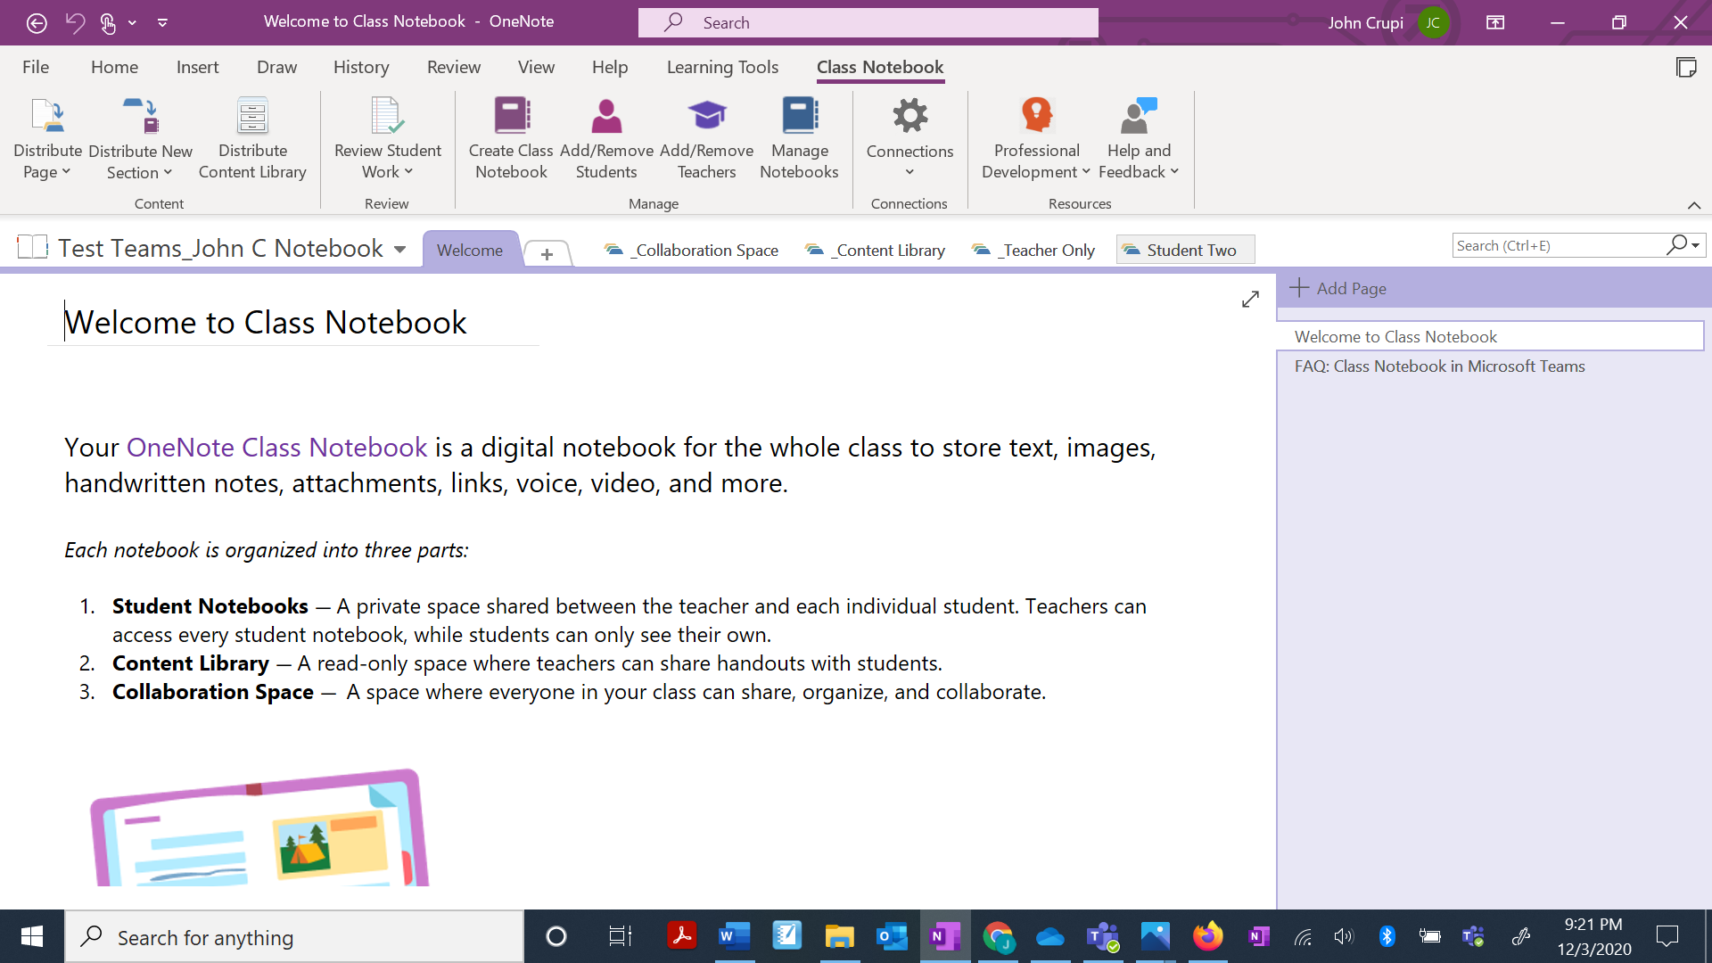
Your “welcome” page.
Your notebook is here with your name on it. Select it.
Collaboration space is where you can work together with your teacher or other students
Teachers have a “teacher only “ space that students can’t view. You don’t have this space.
Content Library – the filing cabinet you are sharing with your students

- When you select your notebook, you should see this screen:
All the pages will be listed here. This is Student Two’s first assignment in the “daily work” section.
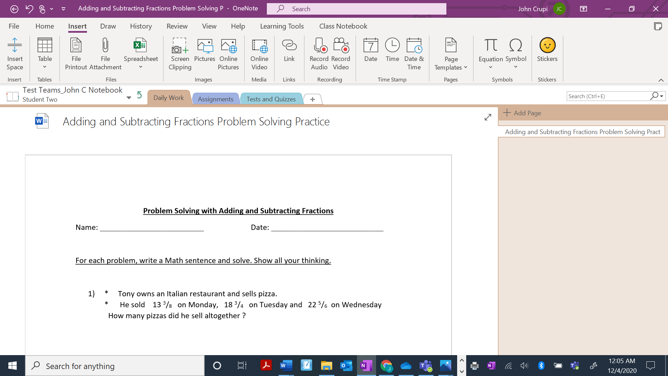
The teacher has sent Student Two an assignment as a “file” and as a “printout”
The teacher has created 3 sections in Student Two’s notebook: daily work, assignments, tests and quizzes. The activity shown is in “daily work”

How Students Complete and Send Assignments To Teachers on Class Notebook

The reason why students should submit their assignments directly in their Class Notebook is because it is much easier for their teacher to mark it. Teachers can edit their pages with their stylus ink/highlighter, add stickers, or even add an audio clip with suggestions for improvement. All changes will be automatically saved in the notebook for the student and teacher to see.

Students can complete their One Note assignments in a few ways:

- If they have a stylus with a touch screen, they can write directly on the document.

- Students can click on the assignment and use their keyboard to type in their responses. This method does not work so well when students need to write out their math solutions.

- Students can open the file and print out the document. Then they can work traditionally using pencil and paper.

- Students can complete their work directly on loose-leaf paper.

- Students who have worked directly on the document don’t need to do anything else.
- Students who opened a Word or PowerPoint document should save it either in a “One Drive” folder or on their device.
- Students who printed off the assignment and worked on it or who completed an assignment on loose-leaf paper should take a picture of each page so they remain as ONE document. I suggest they use the One Drive App on their phone to scan as it places it directly into their One Drive folders (see the document “How to Use One Drive to Scan and Save Documents”).

How Students Attach Assignments in Their Class Notebook So Teachers Can Assess Them
- Students go to their Class Notebook page and click anywhere on the page that they want to insert the file. They should see a cursor. They then select insert>file printout
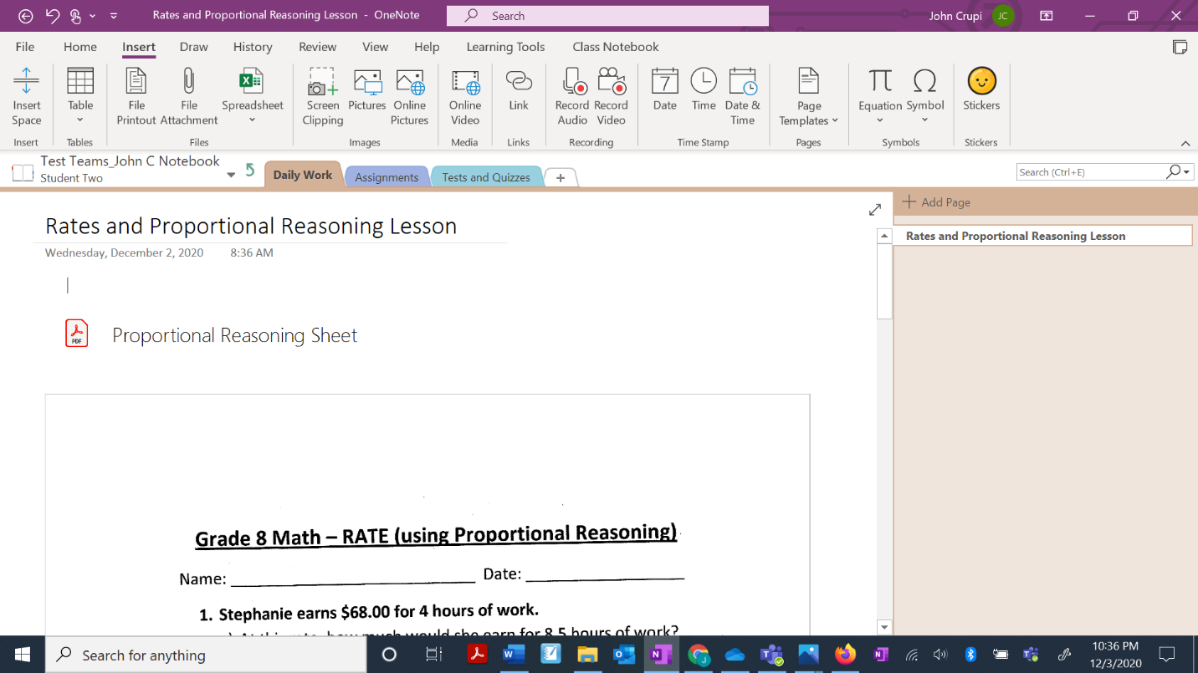
Select Insert, then File Printout
This student has clicked here so the assignment is placed at the top of their page

- Students locate the file they want to insert (from wherever they saved it) and then click “insert”.

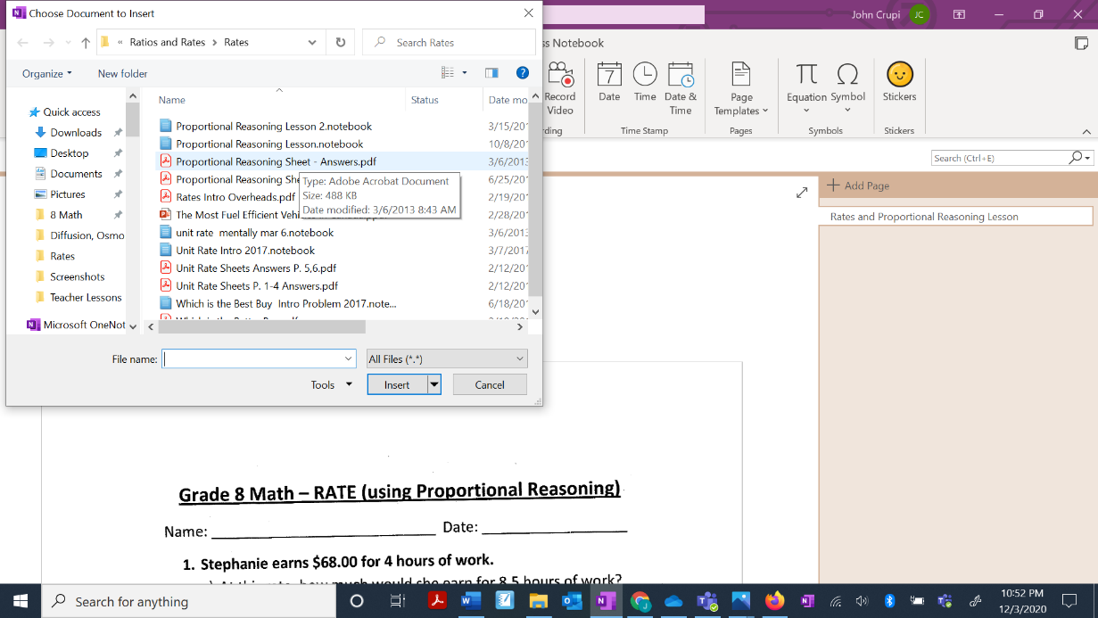
They click “insert” to attach it to their notebook page
Students locate and select the file from where they saved it. This file was saved in ONE DRIVE.
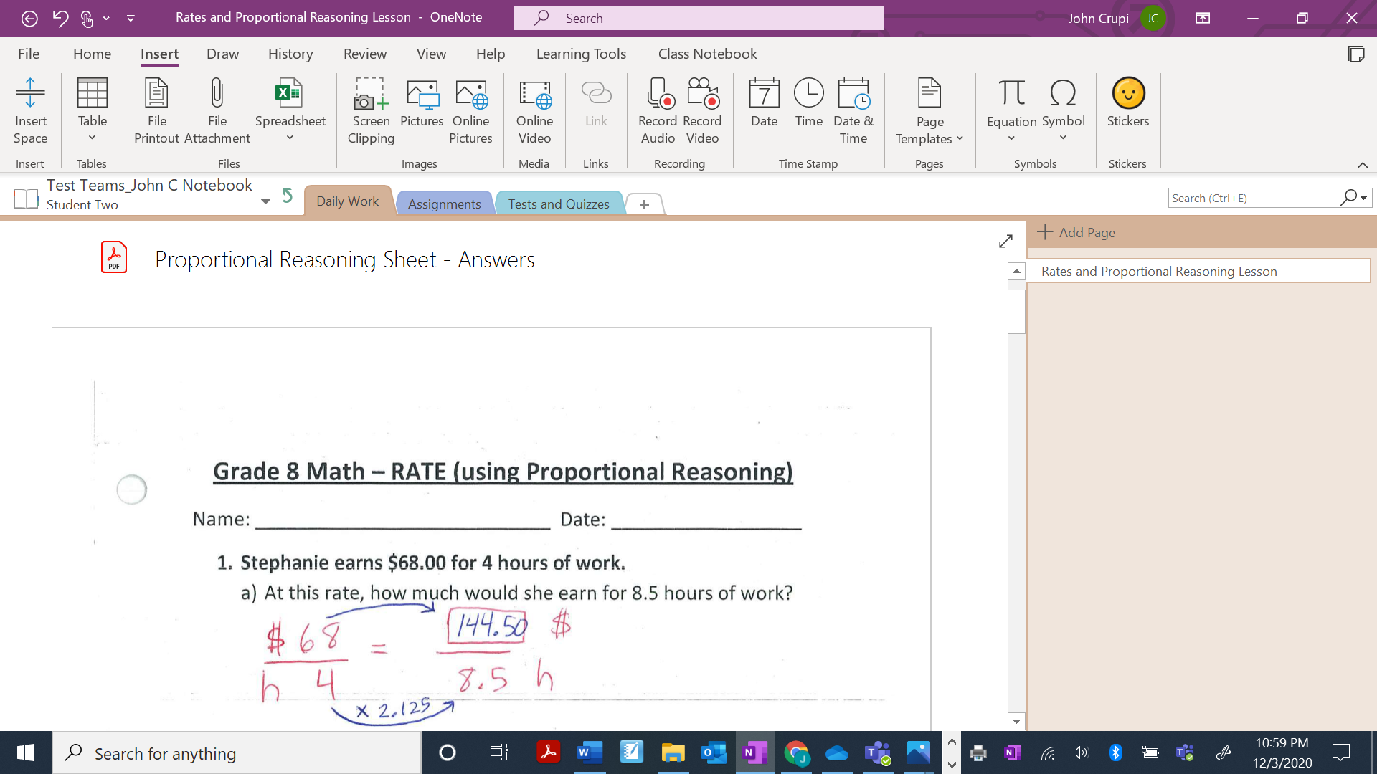
File and printout have been successfully attached to the top of Student Two’s page. The teacher can now mark it.

