How To Use One Drive To Scan And Save Documents

For Students and Teachers

**The One Drive app allows you to scan and save assignments in folders that you have created.**

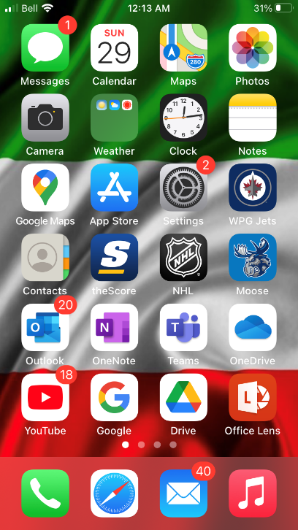 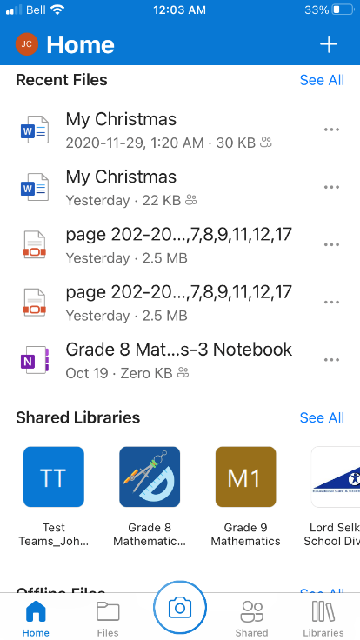 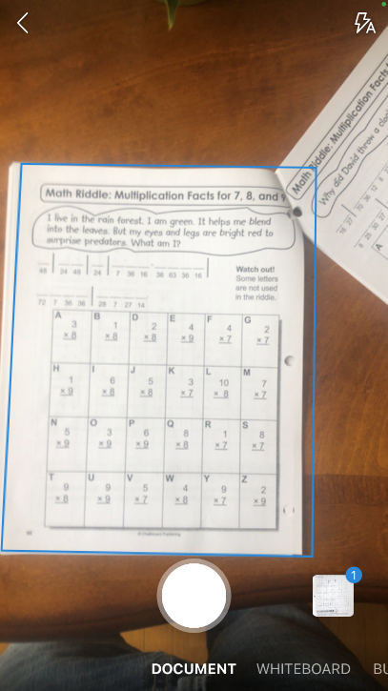

**Press the white button to take the picture**

**Hover over the document until it is surrounded by a blue rectangle**

**Open the One Drive App**

**Select the camera when you are ready to scan**

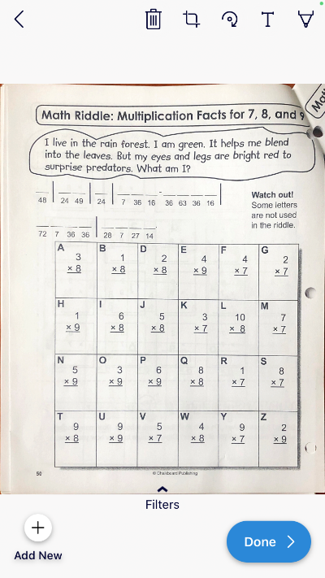 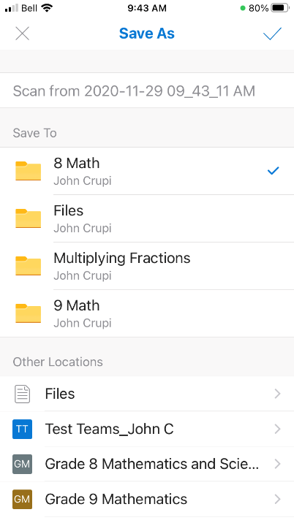 

**Select the checkmark to save**

**Choose where you will save it**

**Name the file**

**Select “done” if you’re done scanning**

**Select “add new” if it is a multi-page document**

**This file will be saved in the “8 Math” folder**

**Select your tool: eraser, 3 ink pens and a highlighter**

**Select the pen to begin marking**

**Select the assignment**