Square Root and Pythagoras’ Theory – Mental Math Test

Name : __________________________ Date: ________________________

Part A: Square Roots 21 marks

- List the first 15 perfect square roots (The first 3 are done for you).
___/4
* √1 = 1 * √4 = 2 * √9 = 3 * _________ * __________
* ________ * _________ * _________ * _________ * __________
* ________ * _________ * _________ * _________ * __________

- Estimate the following square roots. Use the 3 step method as a guide:

a) √17

- Between √ _____ and √ _______ but closer to √ _______
___/2
- Answer is between _______ and ________ but closer to __________
- My estimate is _____________

b) √50
___/2
- Between √ _____ and √ _______ but closer to √ _______
- Answer is between _______ and ________ but closer to ___________
- My estimate is _____________

c) √96
___/2
- Between √ _____ and √ _______ but closer to √ _______
- Answer is between _______ and ________ but closer to ___________
- My estimate is _____________

d) √187
___/2
- Between √ _____ and √ _______ but closer to √ _______
- Answer is between _______ and ________ but closer to ___________
- My estimate is _____________

- What is the length of each square below. SHOW YOUR THINKING. Include units.
a) Area = 169 cm² _____________________________________________
___/3
b) Area = 121 cm² _____________________________________________
c) Area = 6 m² _____________________________________________

4. What is the area of each square below. SHOW YOUR THINKING. Include units.
___/2
a) Length = 7 cm ______________________________________________
b) Length = 9 cm ______________________________________________

- Marco has a square garden with an area of 64 m². He wants to put a fence all around this garden. How many meters of fence does he need altogether? Include units.
___/2

- Stacey has a square garden that has a perimeter of 40 cm. What is the area of this garden? Include units.
___/2

Part B: The Pythagorean Theory 12 marks
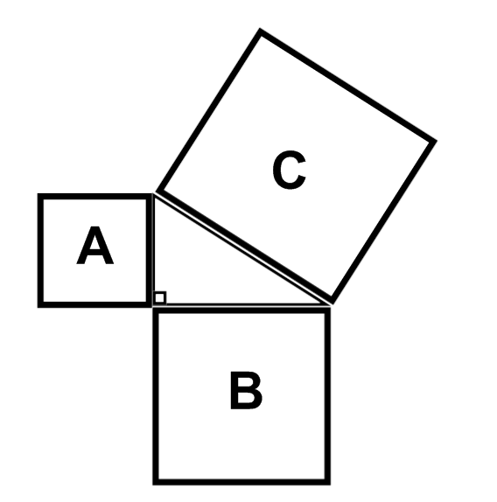

- What is the area of the missing square ?

- Square A = 33 m² , Square C = 55 m², Square B = ________
___/3
- Square A = 16 m², Square B = 28 m², Square C = ________
- Square C = 94 m², Square B = 12 m², Square A = ________

- Which Pythagoras formula would you use to find the missing length of each triangle? (Remember you have a choice of 3).
18 m
- b)
___/2
12 m
12 m
8 m

_________________________________________ _____________________________________

- Estimate the missing length of each triangle. Show thinking. Include units.
7 m
- b) c)
2 m
3 m
10 m
4 m
3 m
___/3

- Suzie leaves home and rides her dirt bike 3 miles east. She then turns north for 4 miles. How far is she from home? Include a simple diagram and show your thinking.

___/2

- A bow hunter is perched at the top of an 8 meter high tree. He shoots a deer with his bow. The arrow travels 10 meters. How far was the deer from the tree? Include a simple diagram and show your thinking.
___/2

